PRACTICAL -3
CSS USING BOOTSTRAP(SCREENSHOT)
INDEX PAGE
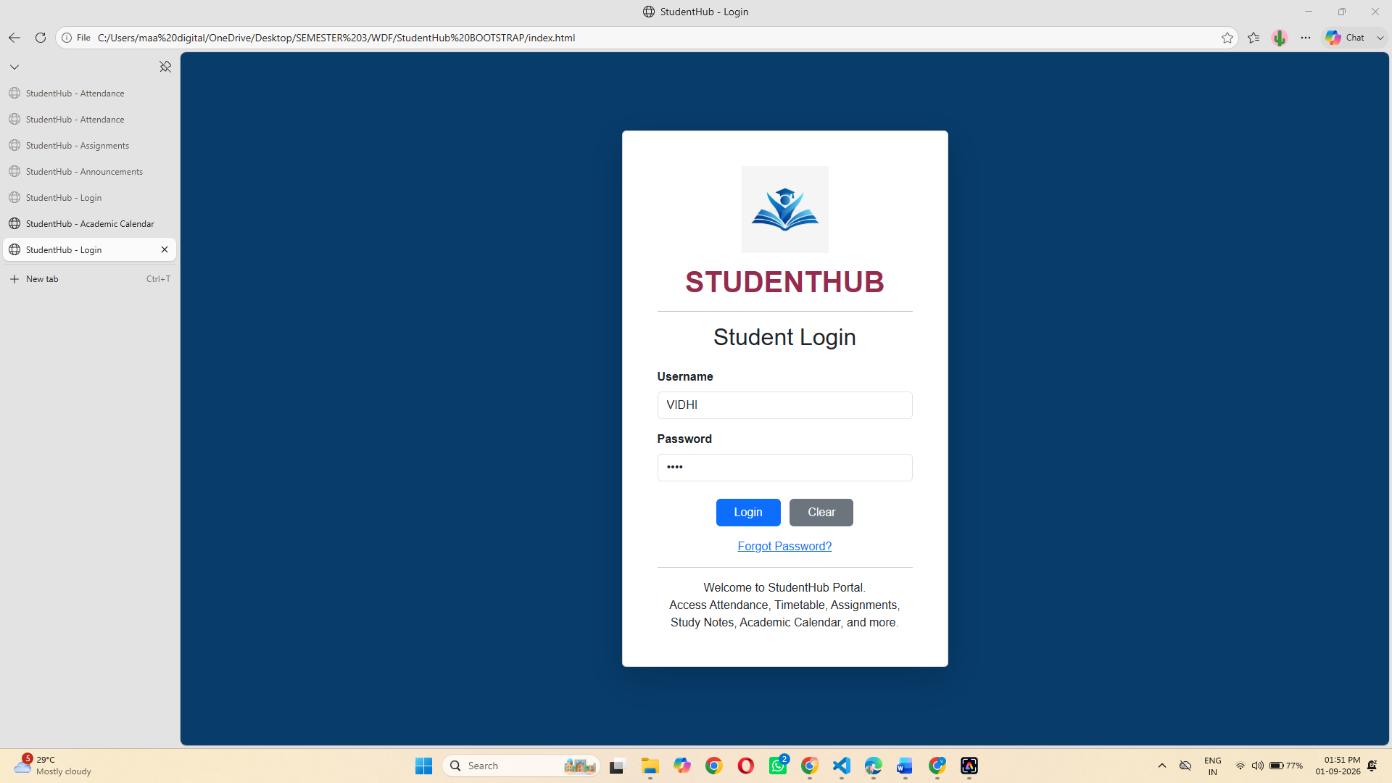

DASHBOARD

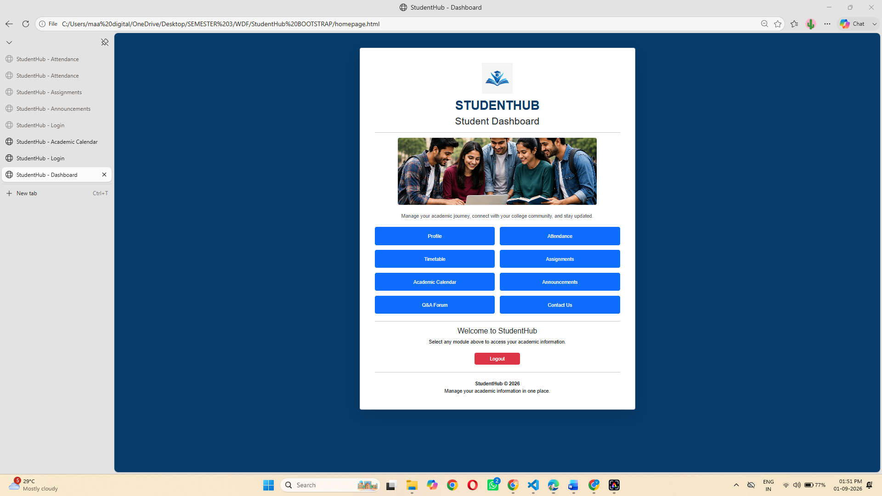

PROFILE PAGE

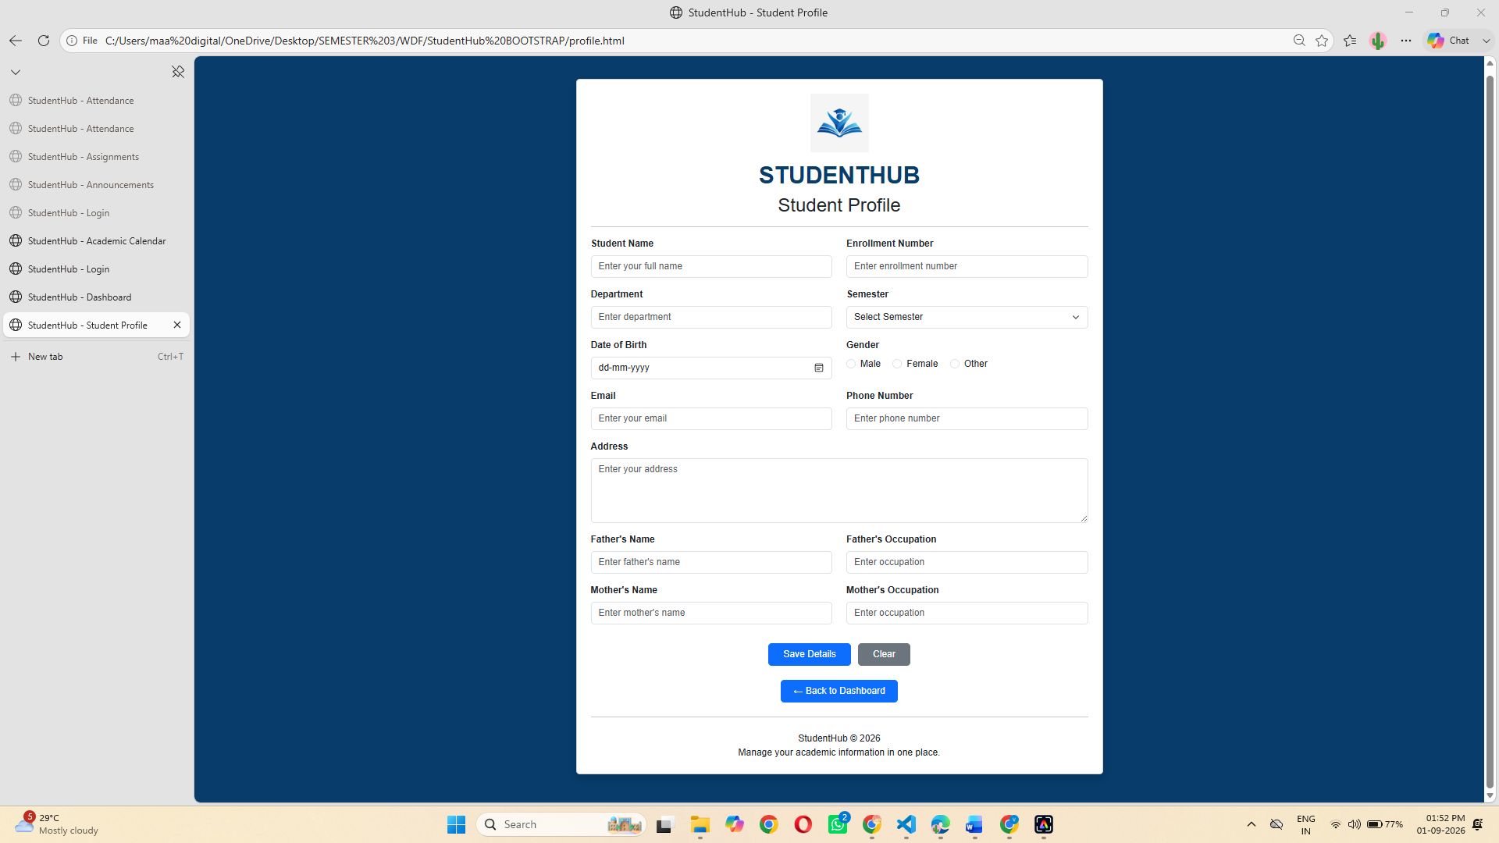
ATTENDANCE RECORD PAGE
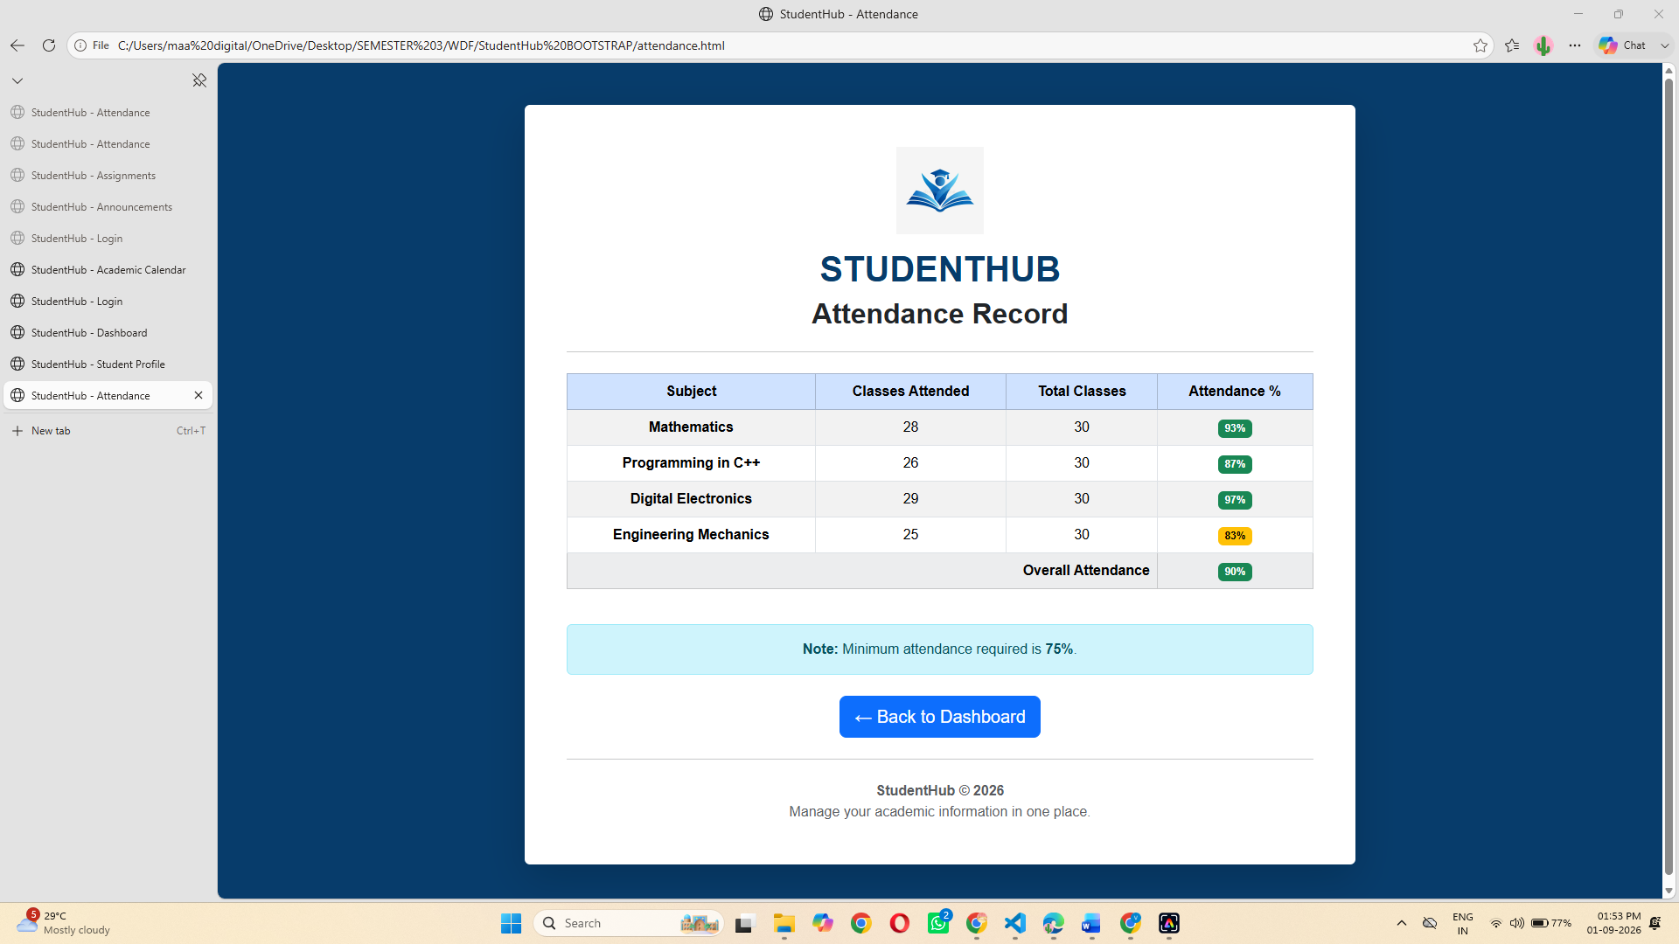

CLASS TIMETABLE PAGE
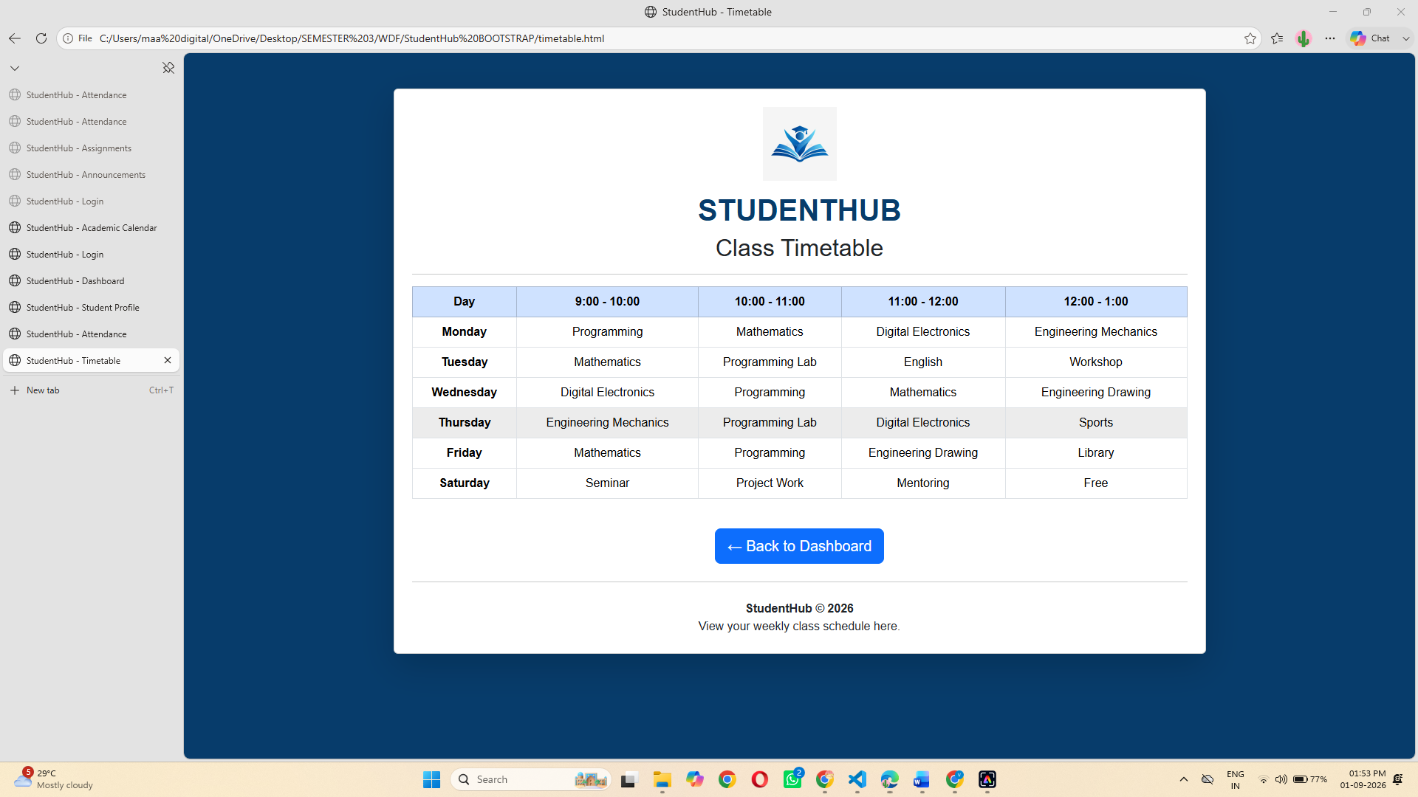

ASSIGNMENTS PAGE

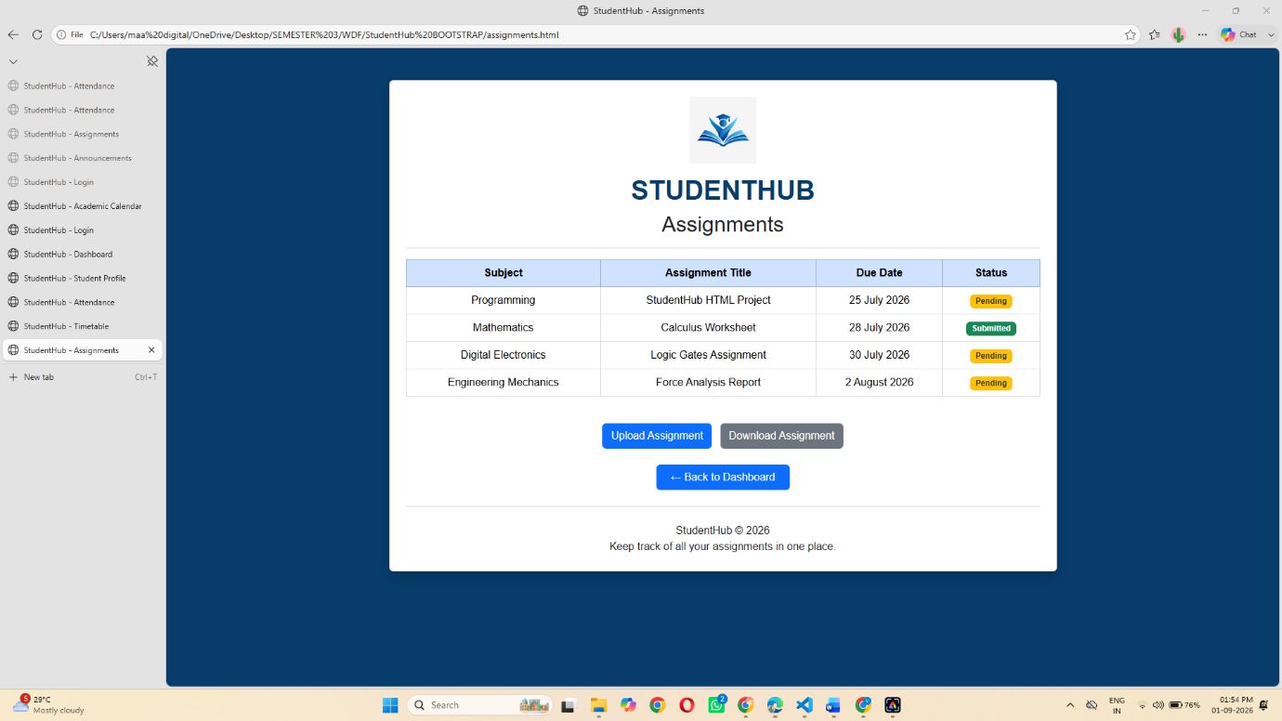

ACADEMIC CALENDAR PAGE
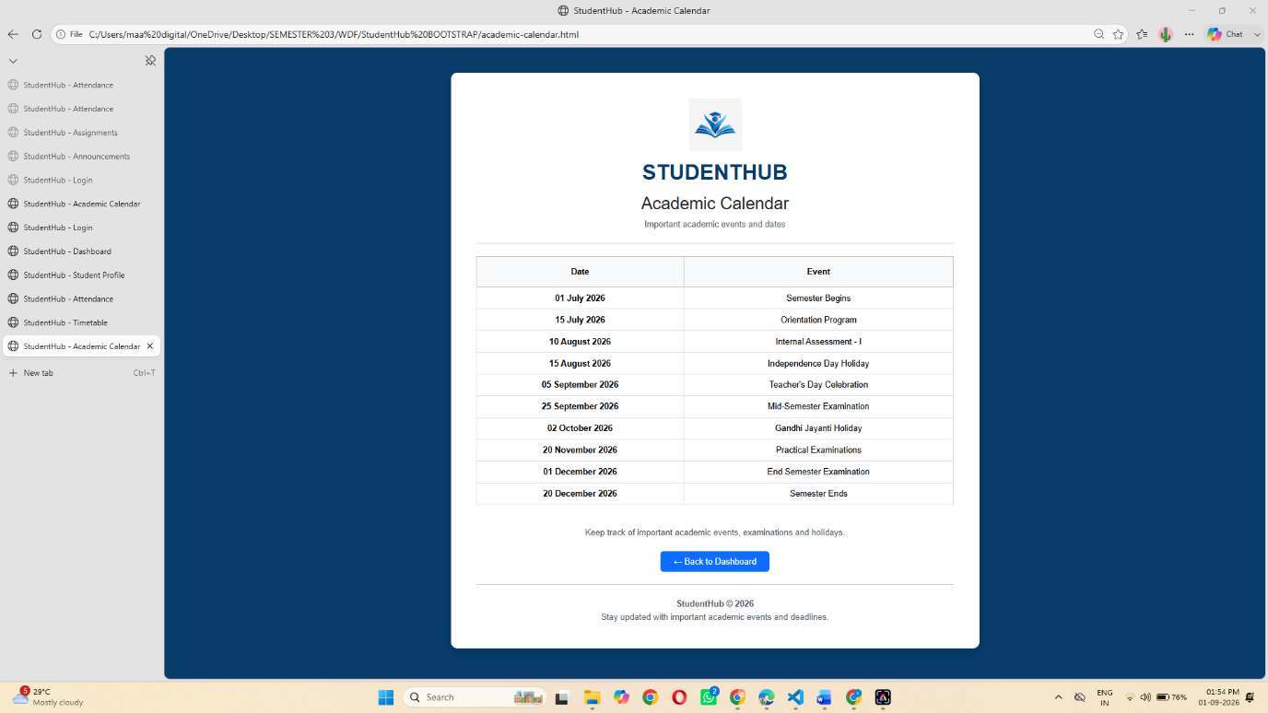

ANNOUNCEMENTS PAGE
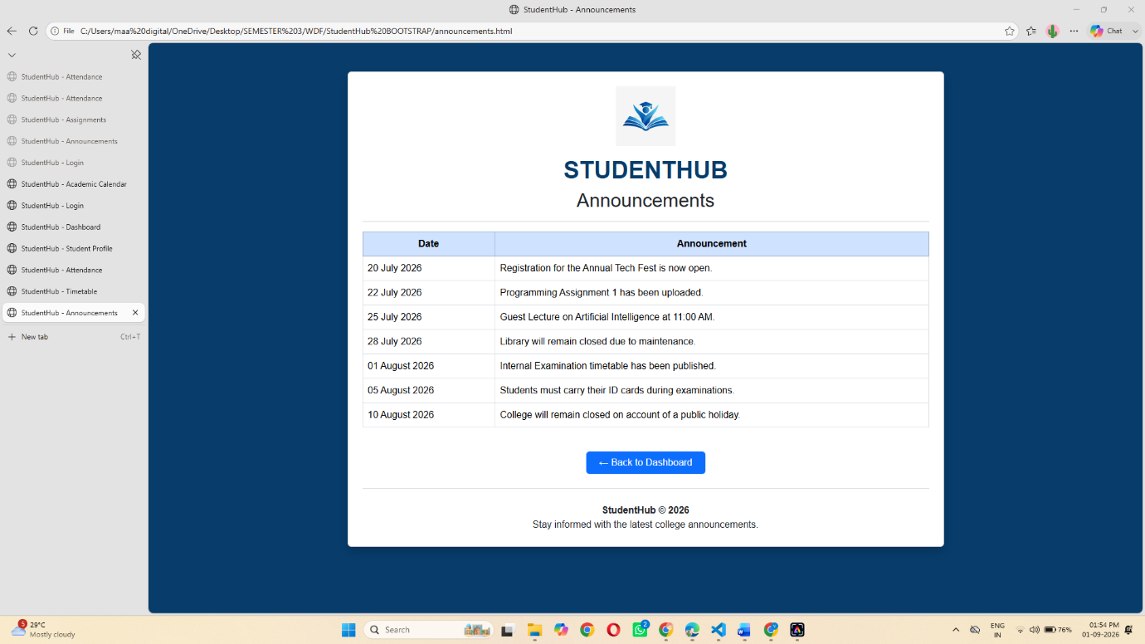

Q&A FORUM PAGE
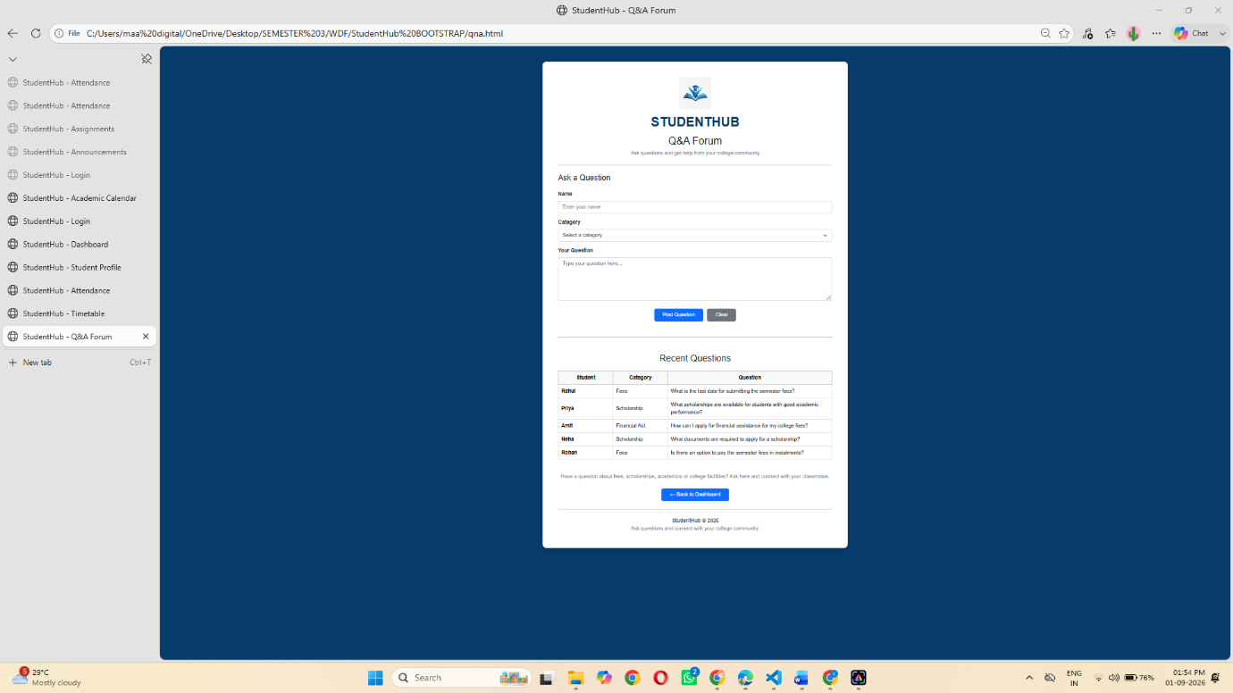
CONTACT US PAGE
